GATE Group: November: “Ish”, Nobody’s Perfect!
Our GATE Group message today was about perfectionism. I found a short children’s book to share together that had a powerful message related to this topic.
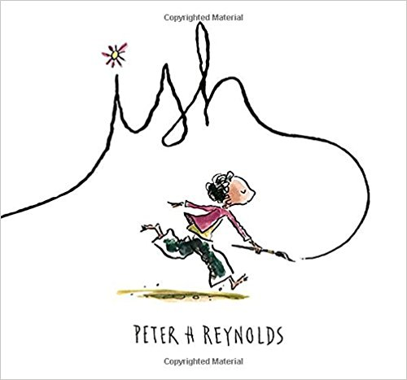
“Ish”, written by Peter Reynolds featured a boy named Ramon who loved to draw. Here is a summary of the book:
Drawing is what Ramon does. It’s what makes him happy. But in one split second, all that changes. A single reckless remark by Ramon's older brother, Leon, turns Ramon's carefree sketches into joyless struggles. Luckily for Ramon, though, his little sister, Marisol, sees the world differently. She opens his eyes to something a lot more valuable than getting things just "right."
Here is A Message from the Author-Illustrator: Peter Reynolds
“Ish” is about not getting squashed by the opinions of others and finding the vocabulary to defend your ideas. I use the” Ish” Approach with kids to help them relax in order to express themselves. Ish-ful strategies can allow art, writing, or problem-solving to flow creatively. You can’t become better at something you don’t do.
This story provides encouragement for children — and grown-up children — to discover, explore, and develop their voice and express it in a unique way. It takes courage to do that, unfettered by self-doubt, unproductive feedback, or preconceived ideas.

After enjoying the read aloud and discussing the meaning behind being “perfect” versus working hard to be better, it was time for our own drawing time. I asked the students to draw a portrait of ME!!! You should have heard the giggles!! I wasn’t sure if the giggles were from nervousness about the task or from the excitement that they were getting the opportunity to draw old Mrs. B.😊
Regardless, your children had a great “adventure in portrait drawing” and all portraits were labeled: “Mrs. B. ish”
We learned from “Ish” that are attempts are more important than our fears. We learned that we need to encourage others to be brave to try new things, to stick up for all people who are trying hard to learn or do something new, and to never think giving up is the answer if you don’t think you can do something perfectly. No one drew Mrs. B.ish perfectly, but the joy we found in all of our art work was what made the learning engaging and powerful.

